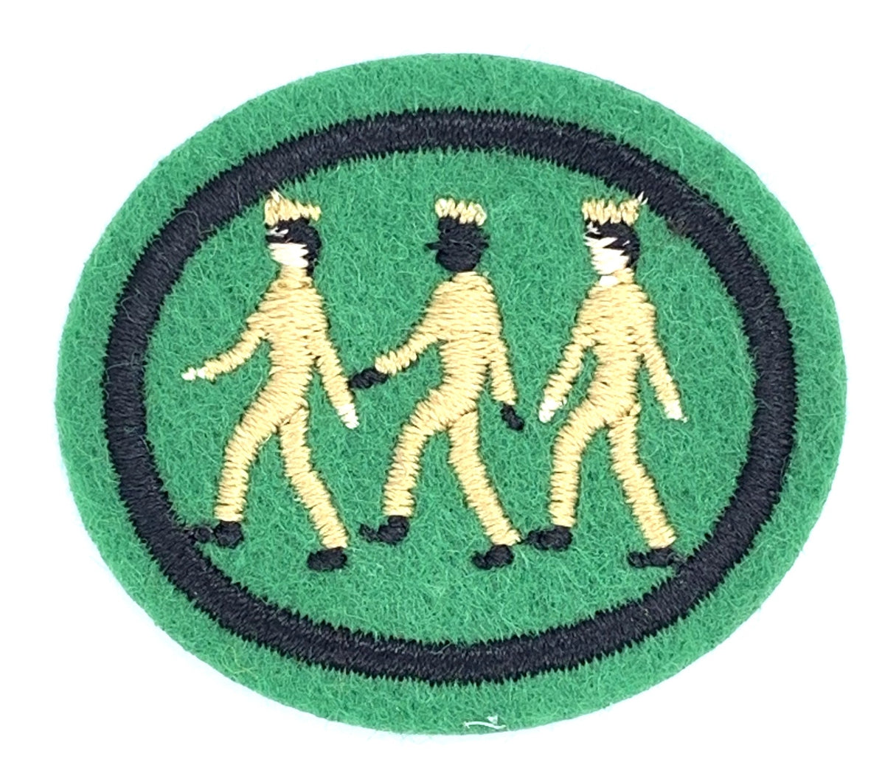

South England Conference

Basic Drilling & Marching Honour Training & Assessment

APPLICATION FORM

Course details: Sunday 4th February 2024 | 12.00-15.00 | The Advent Centre

Club Name
Leader’s Name
Contact No.
Email Address

Please fill in the names of those members from your club planning to attend.
Please also indicate if you are a drummer or MIT.

 | First Name | Surname | Drummer | MIT

Please note, this training is a refresher and assessment and is therefore for those that already have knowledge of drilling and marching. Dress Code: Field Uniform.

Please email this completed form by 28th January to drilldrum@secadventist.org.uk

