PATHFINDER FAIR
INFORMATION
AND
GUIDE

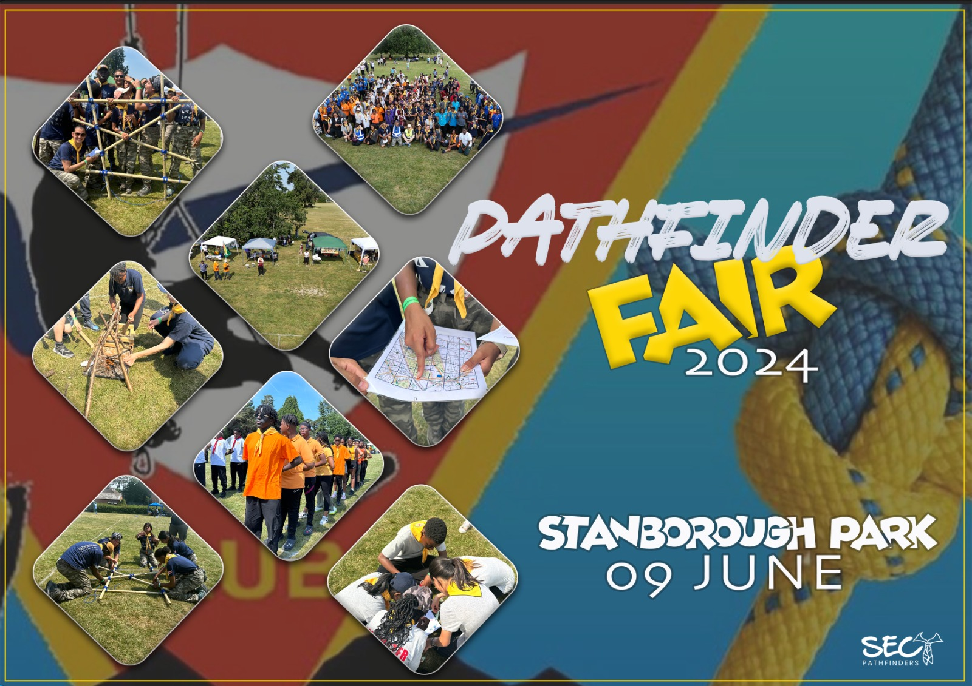

TABLE OF CONTENTS

- Introduction and Philosophy of Pathfinder Fair
- Expectations
- Points
- Fair program
- Preparations for the fair
- Rules of the Fair
- Events
  - Skilled Events
  - Pathfinder Drill Down
  - Formation and Uniform Requirements
- Booths
- General
- Appendix 1 (Skilled Events)
- Appendix 2 (Pathfinder Fair Drill Event)
- Appendix 3 (Semaphore)
- Appendix 4 (Types of Fires)
- Appendix 5 (Chariot and ‘How To’ Lashings)
- Appendix 6 (Field Uniform Inspection)
- Appendix 7 (Fun Games)

INTRODUCTION AND PHILOSOPHY OF PATHFINDER FAIR
The Pathfinder Fair is a gala occasion for the Pathfinder Clubs of a Conference. The chief purpose is:
- For fellowship of Club members across the Conference to increase the sense of belonging to a larger organization which is successful and strong.
- An opportunity to see what other Clubs are doing and sharing ideas.
- A chance for Pathfinders to put into practice their skills which they learnt as part of the curriculum, in a realistic setting.

EXPECTATIONS:
Pathfinder Club members are invited and expected to:
- Come in Field Uniform and be prepared to march in a parade.
- Contribute to a Sustainable Themed Exhibition by creating or making usable or artistic items
- Be Part of the Whole Group Drill Down Event
- Prepare for various Skills Exercises

POINTS:
Pathfinder Clubs will be awarded points toward various standard awards, i.e. Gold, Silver, bronze. Points will be awarded for:
- Proper and Neat presentation of Field Uniform
- Fulfilling various skills exercises according to a required standard, and in an allotted time slot. (See Appendix Below for Skills exercises)
- Execute basic drill formations and commands in front of a live audience.
- Contribution to a Sustainable Themed Exhibition by creating or making usable or artistic items
- Overall presentation, sportsmanship and deportment by the Club and their supporters

FAIR PROGRAM:
The day will be planned as follows (this is an example and may not follow the same procedure on the day):
- 8:00 am: Registration
- 8:00 – 10:00: Prepare and Contribute to Main Booth
- 10:00: Parade, devotion and Opening Exercises
- 10:30 –11:00: Field Uniform Inspection
- 11:00 –12:00: Pathfinder Drill Down
- 12:30 – 13:00: Selected Fancy Drill and Drum Displays
- 12:30 – 13:00: Booth Judging Appreciation and Award
- 13:00 – 14:00: Lunch
- 14:00 – 17:00: Afternoon Skills Events
- Clean Up
- 17:00 – 18:00: Closing Parade
Awards and Presentations
Close

PREPARATION FOR THE FAIR
Preparation for the Fair include:
- Preparing and making crafts and usable items for display and sale.
- Planning and preparing for a creative booth.
- Prepare and practice for the skills exercises
- Prepare and practice the basic drill formations and commands.
- Ensure their club’s field uniforms are ready and in order for inspection.

Registration of your Club’s participation is required by 28 May 2024.

Each attendee will require to contribute an attendance fee of £1 (Including Adventurers, Spectators, and Supporters) which will go toward the organisation and logistics of the event. Please pay at Pathfinder Shop as well as Cash Payment to be taken at the entrance to the Venue.

RULES OF THE FAIR (Subject to Review and Change)
- All registered clubs in the South England Conference are allowed to participate in the Fair.
- Visiting Clubs from other entities will be allowed to participate at the discretion of the SEC Pathfinder Director.
- Experienced Pathfinder Judges will be nominated by the Clubs and be appointed by the SEC Pathfinder Department for the day.
- Judges will award points for:
  - Proper and neat presentation of field uniform.
  - Fulfilling various skills exercises according to a required standard, and in an allotted time slot.
  - Form part of a collective drill down performance.
  - Contributions to the Main Booth.
  - Overall deportment and sportsmanship of club members, leadership and club supporters
- Clubs will register their participation by the agreed closing date.
- Clubs will be required to be in their chosen club Field Uniform (Dark Bottoms with creative T-shirt/hoodie) or Conference field Uniform (Black bottoms, grey t-shirt and either red or grey conference hoodie) for Parade, Drill exercises and for skills events.
- Club Flags, Banners, and Guidons are allowed to identify your club and should be securely placed in front or side of your club booth/ space.
- Clubs who participate will ensure that all staff to be KCFS trained, DBS checked, their club liability and insurances up to date, and their church boards informed and approve of their club’s attendance.
- Registration will be online on Pathfinder Website – ‘secpathfinders.com’

EVENTS:

1. SKILLS and FUN EVENTS (See Appendix 1)
- TRUST-MY-KNOT (KNOT TYING RELAY)
- CHARIOT RACE (LASHINGS OF SIX POLES TO CONSTRUCT A CHARIOT)
- FIRE BUILDING (BUILD 2 FIRES – Fires will not be lit)
- SEMAPHORE (SEND AND RECEIVE MESSAGE REMOTELY USING FLAGS)
- Other FUN EVENTS arranged for the day by the Conference Pathfinder Department

2. PATHFINDER DRILL DOWN EVENT (DRILLING COMMANDS) (See Appendix 2)
Be able to execute a minimum number of Basic Drill Commands as part of a communal exercise. Participants will be eliminated gradually based on mistakes, errors, etc. The last 3 remaining participants will win the Conference Drill Down Award.

3. FORMATION AND UNIFORM INSPECTION (See Appendix 3 for Guidelines and Point System)
The Pathfinder Fair also celebrates the value, importance and the pride of the Pathfinder Field Uniform. Field Uniform, as important as the Dress Uniform, will be inspected for deportment, uniformity, pathfinder logo and high standard. Points will be awarded accordingly and added to overall score.
Uniform must be represented by – Dark Bottoms (No leggings, jeggings, shorts); Club Tishirt or Hoodie (creativity is encouraged) or Conference Field Uniform colours (black bottoms and grey t-shirt/hoodie.

4. MAIN BOOTH
- A main booth will be constructed at the one end of the park
- Clubs are encouraged to contribute to a Sustainable Themed Exhibition by creating or making usable or artistic items
- The theme is Environmental, Sustainability and Reusable.
- Clubs are therefore asked to create items or art from recyclable items.
- Items can be artistic, usable (e.g. bowl, cups, chair, item to be used in the house), or sustainable

Pathfinder’s display in the Booth
The displays that bring out the theme of the Fair, in the areas of crafts, hobbies or any other exhibits. The aim is to show the works of the Pathfinders completed within the clubs.

GENERAL (REQUIREMENTS)

FAIR DOCUMENTS
- Registration Form
- Insurance
- Staff KCFS Evidence
- Church Board Approval
- Fair Schedule
- Pathfinder Medical and Consent Form

CLUB PACKING CHECKLIST
- Unit Guidons (A guidon is a flag showing the name of each unit. These may be handmade.)
- Field Uniform
- Club Banner For Grand Parade
- Booth Supplies for Exhibit
- First Aid Kit
- Skilled Event Resources
CLEAN UP
- Take down Booths and clear area
- Events Area
- Signs
- Resources And Equipment
- Pick up rubbish and dispose in the bin
- General clean-up and personal class and club inspection after sites car park
- Additional Points will be added for Clubs who clean up their area.

APPENDIX 1 ( 4 pages)

TRUST-MY-KNOT (KNOT TYING RELAY)

SKILL SET: Knots learned in Friends to Guide Class

OBJECTIVE: Connect a hessian sack or old blanket by tying a relay of 5 pieces of rope with 6 various knots. The whole team then pulls one pathfinder on the blanket/sack to the starting place.

SIZE OF TEAM: 6 Pathfinders from each club

AGE GROUP: (10-15 years old)

TIME ALLOWED: (Until all knots are tied and whole team safely home)

EQUIPMENT: Each team must have an old blanket, or hessian sack and 4 pieces of rope each 1.5 metres in length and a 5th 3 metres

PROCEDURE: At a signal the first Pathfinder of each team will run to the blanket/ sack, sit down in the middle of it, and tie a SLIP KNOT around the one end of the blanket/sack. When the knot is tied, he raises both hands as a signal to the Pathfinder 2 in line to run forward and tie his rope to Pathfinder number 1, using a SHEET BEND. Pathfinder 2 runs back and touches Pathfinder 3 who runs forward and ties a SHEEP SHANK in his own rope thus shortening the rope. Pathfinder 3 leaves shortened rope on the ground in a neat straight line, then runs back and touches Pathfinder 4 in line, who runs forward to tie Pathfinder 3’s Rope with Pathfinder 2 using a SQUARE KNOT. Pathfinder 4 runs back touching Pathfinder 5 who runs and ties his rope to that of Pathfinder 3 with a FISHERMANS KNOT. Pathfinder 5 runs back to touch Pathfinder 6. Pathfinder 6 ties a BOWLINE with his own rope around his waist and runs to tie his rope to that of Pathfinder 5 using a SHEETBEND. Pathfinder 6 raises his hand and the whole team runs toward him then together pull the joined ropes with Pathfinder 1 on the blanket/sack until the starting line.

If any knot comes undone during any point in the process, the responsible Pathfinder needs to go back and re-tie the correct knot.

Trust-My-Knot – Scoring Card
Each participating club get 15pts – 80 max points
Appendix 1 (Pg. 1 of 4)
Club Name: | Trust-My-Knot
Criteria | Score
Speed Score (8mins or under) (15pts) | /15
Accuracy of Knots Score (5pts per knot) | /35
Position Score (1st , 2nd , 3rd ) | 15 10 5

CHARIOT RACE (LASHINGS OF SIX POLES TO CONSTRUCT A CHARIOT)

SKILL SET: Lashings learned in Pathfinders

OBJECTIVE: Lash a ‘Roman Chariot’ in the form of a rectangular trestle frame, and drag a team member on the chariot back to the starting point.

SIZE OF TEAM: 3-5 Pathfinders from each club

AGE GROUP: (10-15 years old – FRIEND TO GUIDE CLASS)

TIME ALLOWED: (Until the whole team finish the race with chariot intact and rider staying aboard)

EQUIPMENT: Each team must have 6 round poles of about 1.5 metre in length and about 6 inches in diameter, 9 pieces of rope each 2 metres in length.

PROCEDURE: On signal, the team lashes together a “chariot” in the form of a trestle frame, similar to trestles used in bridge building: (See attached Picture)
- Four poles lashed into a square, using SQUARE LASHINGS and begin and end with a CLOVE HITCH,
- Fifth and sixth poles lashed diagonally using DIAGONAL LASHINGS to opposite sides, beginning with a TIMBER HITCH and ending with a CLOVE HITCH.
- The end of the Fifth and Sixth Poles attached to the square poles using SQUARE LASHINGS beginning and ending with a CLOVE HITCH.
- Tie a 2 metres long rope to the top pole as a ‘Rein’, using CLOVE HITCHES.
When frame is finished and “reins” attached, two team members pull chariot
and a rider down the field around a marker and back.

If any lashing or knot comes undone during any point in the process, the responsible Pathfinder
needs to go back and re-tie the correct knot or lashing

Chariot Race – Scoring Card
Each participating Club gets 15pts – 85 max points.
Club Name: | Chariot Race
Club Participation. /15

Criteria |  | Score
Speed Score (12mins or under) (15pts) |  | /15
Accuracy of Lashings/Knots Score  (Expected knots/lashings: x8 Square Knots, x19 Clover Hitch, x1 Timber Hitch, x1 Diagonal Lashing Knot)  All correct = 40pts / 14 or more correct = 20pts / 13 or less = 10pts |  | /40  (All correct)
Chariot holds for entire course |  | /10
Position Score (1st , 2nd , 3rd ) |  | 15 10 5

Appendix 1 (Pg. 2 of 4)
FIRE BUILDING (BUILD 2 FIRES)

SKILL SET: Fire Building in Friend to Guide Class (Some may have done it in Advanced Class)

OBJECTIVE: You will be required to build 2 different fires within a specific time.
    - One fire will be a fire that you may use to cook food on
    - One fire will be a fire that you may use to keep you warm

SIZE OF TEAM: 3-4 Pathfinders from each club

AGE GROUP: (10-15 years old – FRIEND TO GUIDE CLASS)

TIME ALLOWED: 5 minutes

EQUIPMENT: Each team must have necessary materials prepared to build any of the fires below.
Water, fire tray, fire extinguisher,

PROCEDURE: You will be told which fire you are required to build before you begin:
    - Log Cabin Fire
    - Reflector Fire
    - Wigwam/Teepee Fire
    - Crane Fire
    - Council fire

You will need to choose the correct type of material to use for your specific fire.
You must work as a team
On signal, you may begin your fire build.
For the cooking fires, you will need to simulate a cooking scenario, either boiling, baking or frying

Fire Building – Scoring Card
Each Participating Club gets 15pts – 85 max points

Club Name: | Fire Building
Criteria | Score
Quality of Build Score | /10
Appropriate Fuel | /15
Speed Score Lighting (3mins or under) (15pts) | /5
The Fires stays Lit Score (2mins) | /25
Position Score (1st , 2nd , 3rd ) | 15 10 5
Appendix 1 (Pg. 3 of 4)
Appendix 1 (Pg. 3 of 4)
SEMAPHORE (MORSE CODE TYPE MESSAGE RELAY WITH FLAGS)

SKILL SET: Administer Semaphore in an emergency situation

OBJECTIVE: You will be required to:
- Send and Receive a message correctly and accurately within an allocated time frame, using semaphore code and semaphore flags.
SIZE OF TEAM: 4 Pathfinders from each club
- 1 - To Read The Sending Message.
- 1 - To Send The Message.
- 1 - To Receive And Repeat The Message
- 1 - To Write The Received Message

AGE GROUP: (10 -15 years old – FRIEND TO GUIDE CLASS)

TIME ALLOWED: 5 minutes

EQUIPMENT: Each team must have the following equipment:
    - 4 Semaphore Flags
    - Pen And Paper

PROCEDURE: The Instructor will send a 34-36 letter message to one team member. That team member will signal to the other team member who will then report message to the instructor.
Example of messages:
- Go on God’s errand equals I will go today. 34
- To enjoy camping, learn the six rules. Be safe. 35
- Jesus will soon come. Ready pathfinders. 35

Semaphore – Scoring Card
Each Participating Club gets 15pts – 79 max points

Club Name: | Semaphore
Criteria | Score
Speed Score (10 mins or under) (15pts) | /15
Correct Code Reading (1pts per letter) | /34
Position Score (1st , 2nd , 3rd ) | 15 10 5
APPENDIX 2 (1 page)
Appendix 1 (Pg. 4 of 4)

PATHFINDER FAIR DRILL EVENT
DRILL AND MARCH DEMONSTRATION INFORMATION
- Pathfinders must remain in Field Uniform until after they have finished their Drill and March demonstration.
- Your Club will fall in with the rest of the Clubs according to the Drill Instructor’s instructions.
- The Drill Instructor will issue the following basic drill commands randomly to the whole group.
- Appointed Judges will monitor the group and watch out for any errors and hesitations from anyone in the group. A process of elimination will follow as a result.
- The elimination will continue until the last 3 candidates remain.
- The last 3 candidates will receive the day’s Drilling Prize.
SKILL SET: Basic Drill Commands

OBJECTIVE: Be able to execute a minimum number of Basic Drill Commands within a set time frame, in front of a set of dignitaries and live audience.

SIZE OF TEAM: The Drill Team must:
- Consist of Pathfinders, TLTs and/or Master Guides
- Be registered members of the Pathfinder Club they represent (Club must be officially recognised by the South England Conference)
- Consist of a minimum of 6 people

AGE GROUP: 10 - ? (Pathfinders, TLTs, Master Guides)

TIME ALLOWED: Time allowed until last 3 candidates remain.

EQUIPMENT: Field Uniform

PROCEDURE: 1. The routine is to be a rehearsed routine without commands
2. The length of the routine must not exceed 4 minutes
3. Creativity is left to the team, however, the following movements must be included:

- Attention
- Stand at Ease
- Dress Right Dress
- Salute
- Left Turn
- Right Turn
- Left and Right Incline
- Prayer Attention
- About Turn
- Fall Out
- Mark Time
- Forward March
- About Turn on the March
- Halt

Appendix 2 (Pg. 1 of 1)
Appendix 2 (Pg. 2 of 2)
APPENDIX 3 (1 Page)

PATHFINDER FAIR – SEMAPHORE
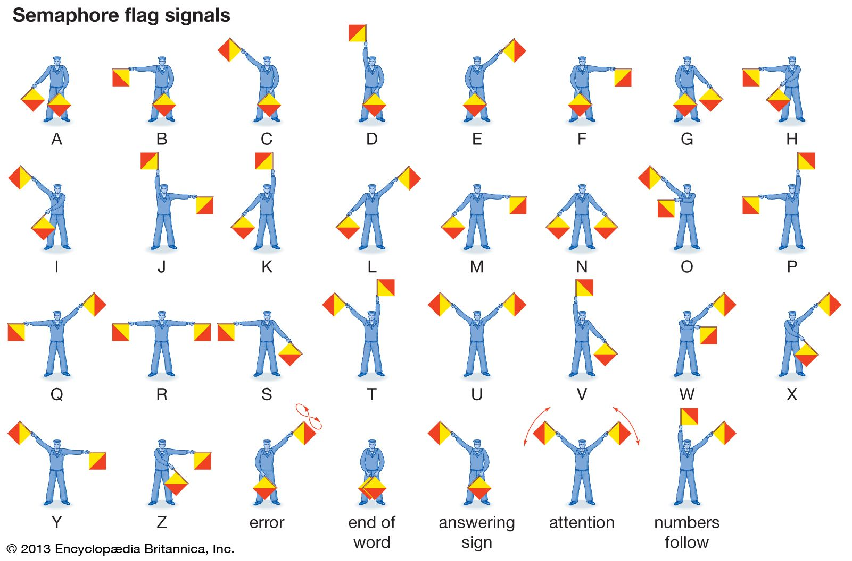
Appendix 3 (Pg. 1 of 1)
APPENDIX 4 (2 PAGES)

TYPES OF FIRES

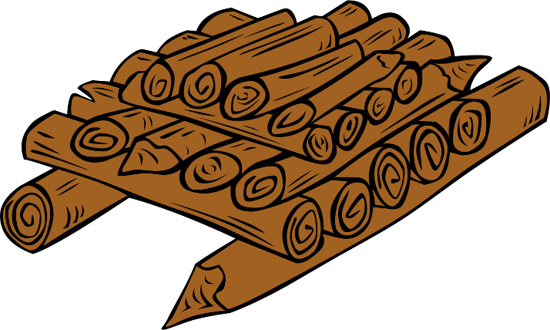
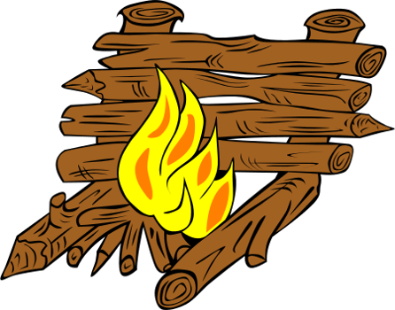
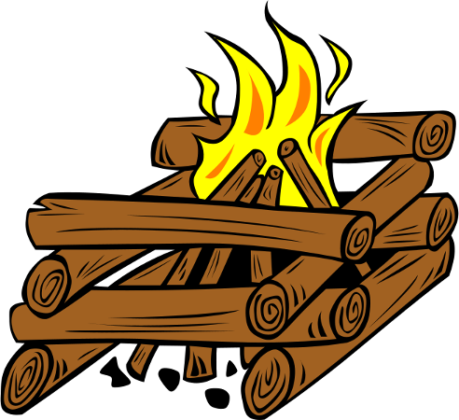
Appendix 4 (Pg.1 of 2)
LOG CABIN FIRE
The log cabin is easy to lay, and it is fairly stable as well. It is laid very much like a log cabin (hence the name). It is somewhat difficult to light though, as the fuel is off to the side of the tinder and kindling. When it burns, it falls in on itself, confining itself to the fire ring. It is also easy to add more fuel and maintain a neat orderly fire.
COUNCIL FIRE
The council fire was used by Native Americans during their meetings (or councils). It is very much like the log cabin fire except that more than two logs are laid on each layer. Be careful not to lay the logs too close to one another. Leave gaps of at least one inch (2.5 cm) between each log to allow air to circulate. Like the log cabin fire, the council fire is very stable, and it falls into itself as it burns, remaining within the fire ring. Unlike the log cabin fire, the council fire lights easily as the main fuel is located directly above the kindling and tinder where convection will carry the flames. This fire is hot, and will make a nice bed of coals for cooking. It also uses a lot of fuel. This fire is sometimes called a pyramid fire as well.

REFLECTOR FIRE
This fire can be used for baking. The fire itself can be of any other form, and is placed in front of the reflector. This fire is also good for getting oneself warm. If you sit (or sleep) between the reflector and the fire, the side of you facing the fire will be warmed directly, while the reflector throws heat to the opposite side. Very toasty.
You will be making the reflector from logs, which means the vertical members should be driven deeply into the ground to support the weight of the horizontal members. You can also use rocks to support them.

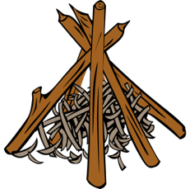
THE TEEPEE (WIGWAM) FIRE
The teepee fire is probably the most recognized campfire. It is somewhat difficult to lay however, as getting the logs to balance against one another can be tricky. Sometimes the log pile will topple and upset the kindling and tinder beneath, and you'll have to start again from scratch. If necessary, you can lash them together at the top with twine (but don't use a synthetic rope such as nylon or polypropylene). Once laid, the teepee fire is very easy to light, as convection will take the flames right to the fuel.

CRANE FIRE
The Crane fire is a type of fire build to support a hanging pot over a fire. You can make the crane in various ways. A long stick with a weight on the back propped over a log or rock will work fine. Feel free to use whatever is handy for propping up a crane. A large rock or two work as well as a log for this crane.

This crane on the left, allows for adjusting the heat of cooking by raising or lowering the cooking pot over the fire. By spiraling the piece of rope around the large stick, you can raise and lower the pot by twisting the stick to wind on more rope, or release more rope. The tripod could also be a forked branch driven into the ground

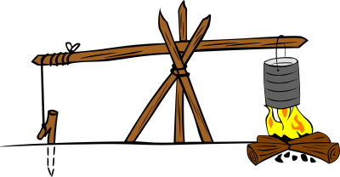
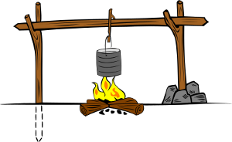
Appendix 4 (Pg.2 of 2)
THE DOUBLE SUPPORT CRANE on the left is supported on both sides of the fire. It is a popular choice and provides a stable crane. As seen on the right hand forked branch, use a small pile of rocks to hold the vertical supports where the ground is too hard to drive in a branch.
APPENDIX 5 (2 PAGES)

ROMAN CHARIOT AND LASHINGS INSTRUCTIONS
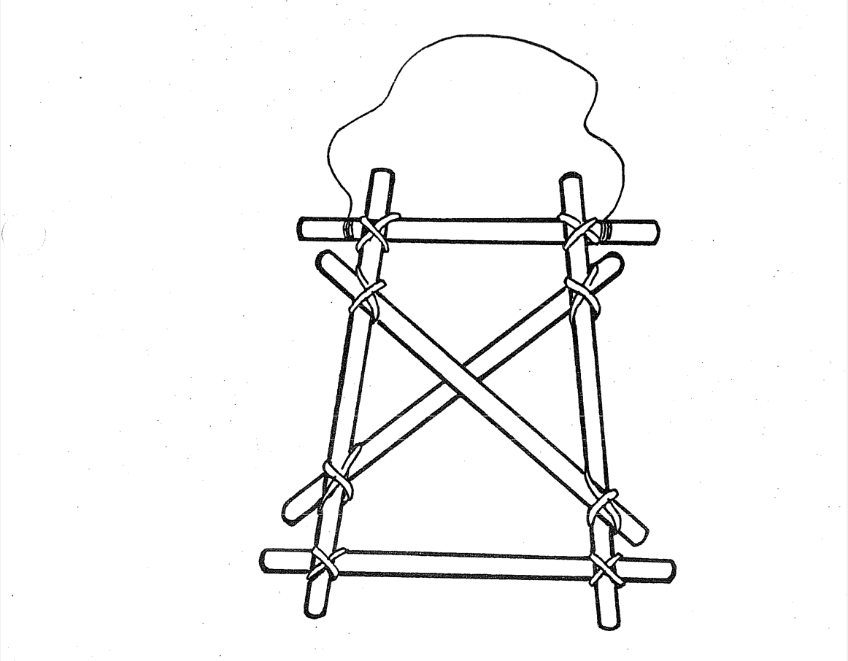
Square
Lashings
Clove Hitch
Diagonal
Lashings

TIEING A SQUARE LASHING
Appendix 5 (Pg. 1 of 2)

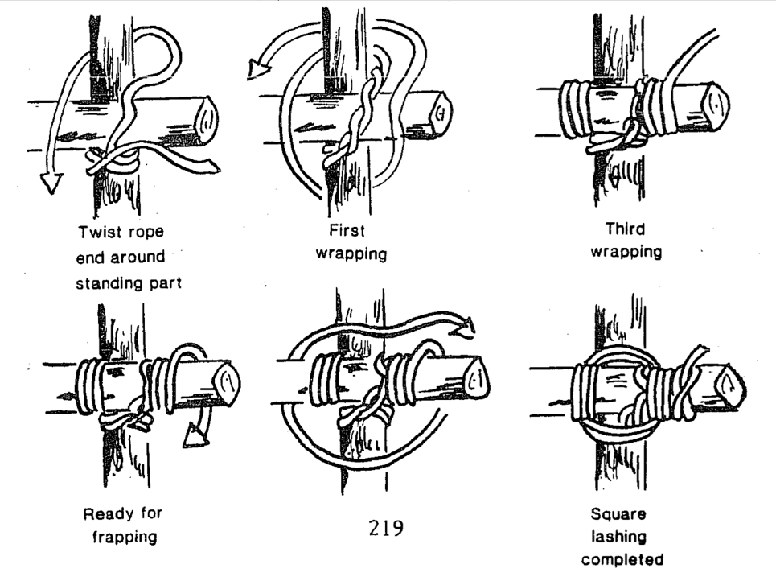

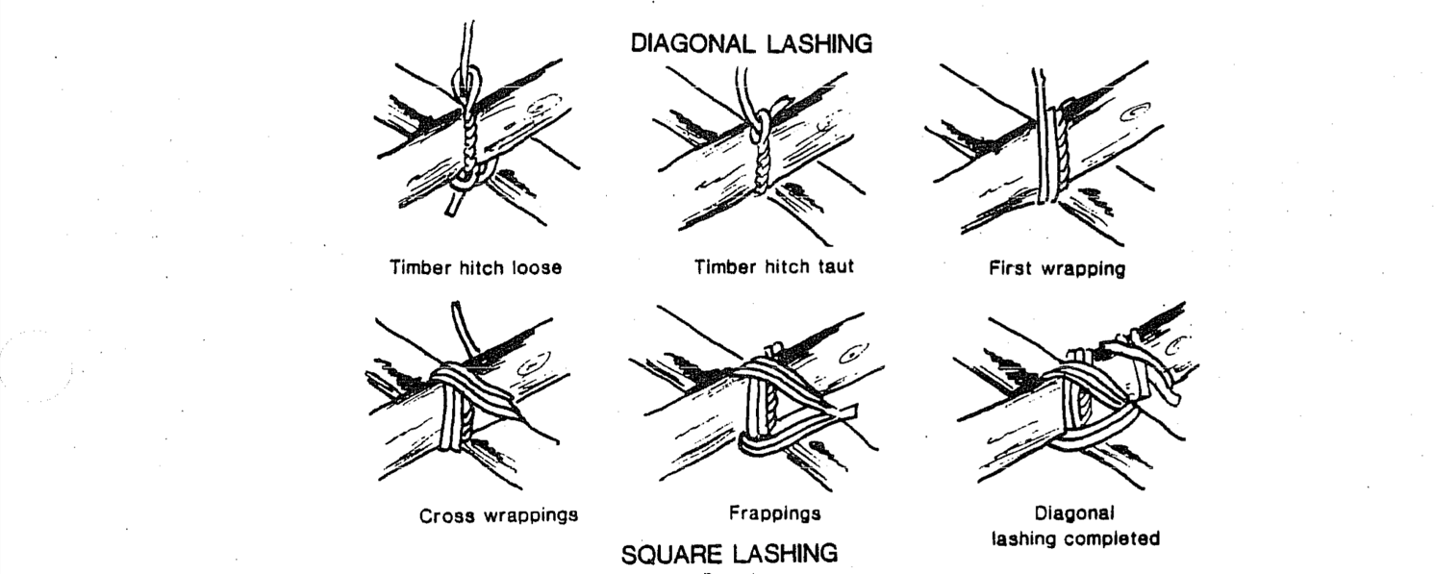
Appendix 5 (Pg. 2 of 2)
Pathfinder Fair Uniform Inspection

Name of Club ______________________________________

Attendee Inspection | One point Per Item  (Group overall) | Number of Missing Items  (Per Pathfinder)
Scarf, Yellow with logo | i.e. 10 pts – 10/10 | 0
Pathfinders Woggle | i.e. 5 pts – 9/10 | 1/10
Grey t-shirt or Club t-shirt | i.e. 5 pts – 8/10 | 3/10
Plain Dark Bottoms  (Club bottoms – no leggings/  jeggings) | i.e. 0 pts – 3/10 | 7/10
Total Point | i.e. 30/ 50 max points
Inspectors Name

- Uniform scoring Guidance = If all members have corrected uniform item award 10pts
(per category i.e. scarf)

- If 1 or more (more than 50%) members are missing a uniform item award that club 5 points for that uniform category.

- If more than half the club is missing a uniform item, award the club 0 points for that uniform category.

Appendix 6 (Pg. 1 of 1)
FUN EVENTS

Relay – Scoring Card

Each Participating Club gets 15pts – 45 max points

Club Name: | Orienteering
Inform teams of games ! 5 games approx.
Criteria | Score
Speed Score (8 mins or under) (15pts) | /15
Position Score (1st , 2nd , 3rd ) | 15 10 5

Tug of War

Each Participating Club gets 15pts – 45 max points

 | Orienteering
Criteria | Score
Position Score (1st , 2nd , 3rd ) | 30 20 10

Surprise Fun Game 3

 | Orienteering
Criteria | Score
Position Score (1st , 2nd , 3rd ) | 30 20 10

Total Points:
- Uniform – 50
- Trust-my-Knot – 80
- Chariot Race – 85
- Fire Building – 85
- Semaphore – 79
- Relay – 45
- Tug of War – 45
- Game 3 – Bonus

Total amount of points: 469
Appendix 7 (Pg. 1 of 1)

